Office of  Chief William A. Horne  (910) 324-5777  (910) 324-2324 fax  rpdchief@richlandsnc.gov | Richlands Police Department  Richlands, North Carolina  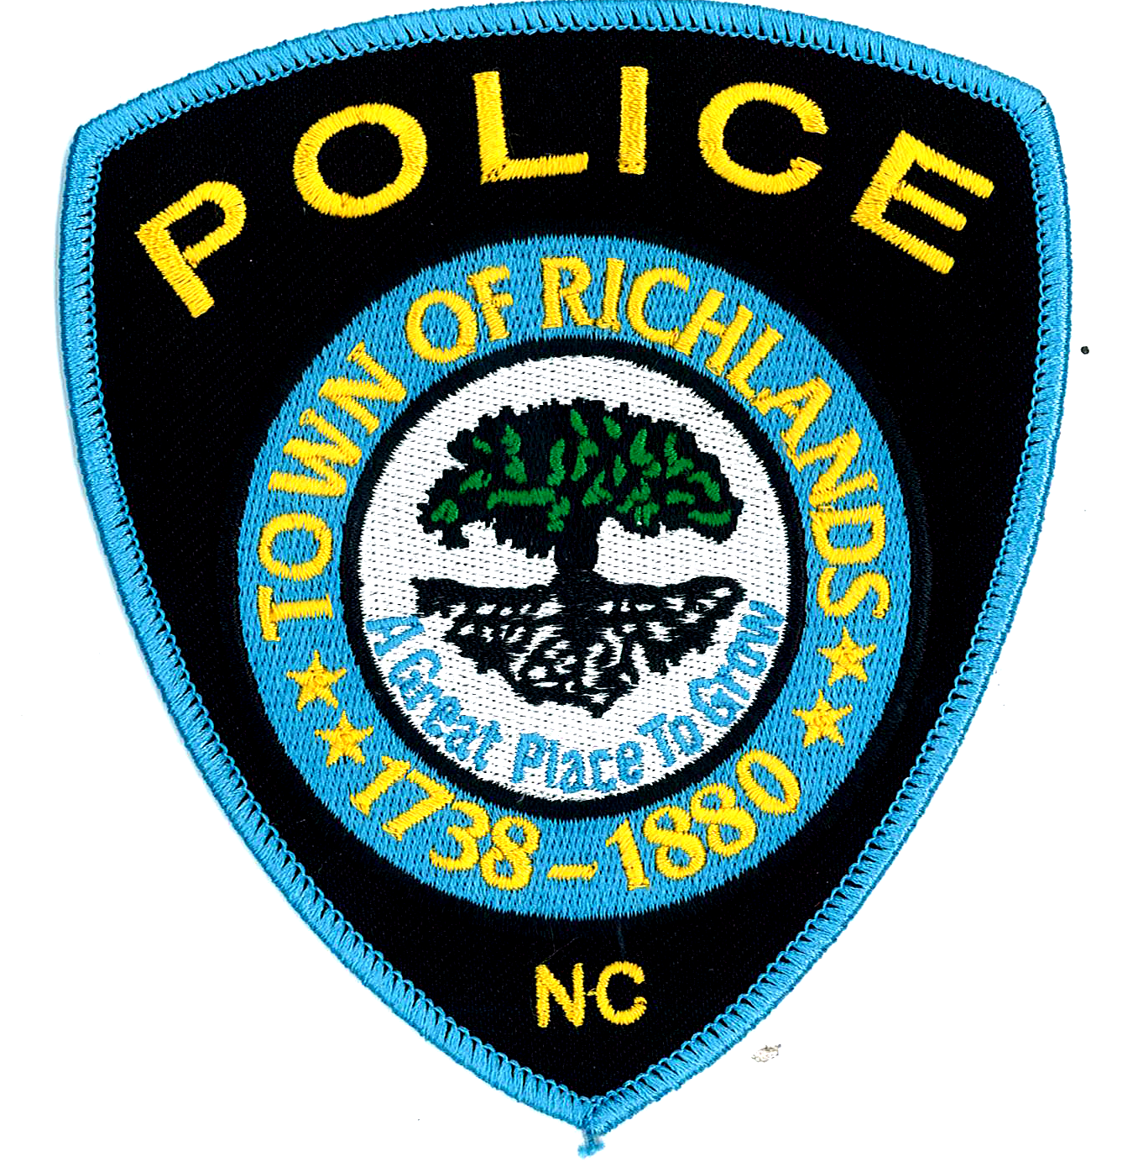 | Mailing Address:  P.O. Box 245  Richlands. N.C. 28574

The Richlands Police Department is currently hiring for the position of Police Officer. Applications can be picked up and submitted at Town Hall along with a notarized copy of the Law Enforcement Training and Standards F-3 form, Monday thru Thursday, 0800-1700 and Friday 0800-1200. (only BLET Certified individuals need apply at this time).
Applicants for the position of Police Officer with the Richlands Police Department must:
- Be 20 years of age or older upon date of employment
- Pass a medical examination
- Be a Citizen of the United States
- Be a high school graduate or possess an equivalency certificate
- Possess a valid North Carolina driver's license
- Have no convictions of a felony or serious misdemeanor
- Submit to a thorough background investigation Position

Benefits

- Retirement:
- Law Enforcement Officers Retirement System (LEORS): You qualify for full (or unreduced) retirement benefits at age 55 and complete five years of creditable service as an officer, or 30 years of service, at any age.
- Special Separation Allowance: Provides an annual benefit equal to 0.85% times the years of service times the final base annual salary of the employee, payable from the date of retirement until age 62.

- Insurance: • Medical, dental, vision, and life insurance provided at no cost to the employee. Family plans are available at an additional cost.

- Other Benefits:
- Uniforms and Equipment
- Paid Holidays
- Vacation/Sick Leave
- Workers' Compensation
- Competitive Salaries
- Take Home Car Program within defined area

